**Power BI Visuals: Comprehensive Documentation with Definitions, Types, and Real-World Use Cases**

Power BI offers an extensive collection of visualization types designed to transform raw data into meaningful insights. Each visual serves specific analytical purposes and excels in particular scenarios. This comprehensive guide covers all major Power BI visuals with detailed definitions, types, and practical use cases enhanced with visual examples.

**Bar and Column Charts**

**Definition :**

**Bar charts** display data using horizontal rectangular bars, while **column charts** use vertical bars. The length or height of each bar represents the value of the data point.[1][2][3]

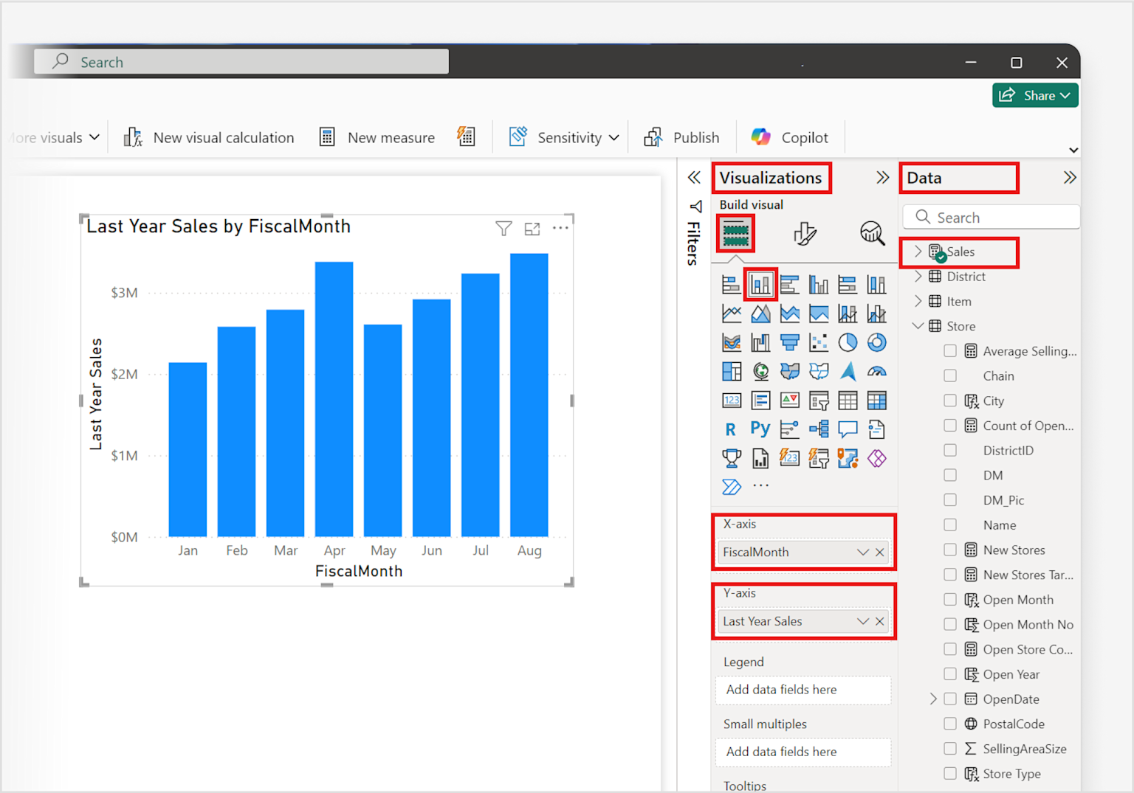

Power BI interface showing creation of a column chart with last year sales by fiscal month, highlighting visualization selection and data field assignments.

**Types :**

* **Clustered Bar/Column Charts**: Compare multiple data series side by side within each category[3][4]
* **Stacked Bar/Column Charts**: Stack multiple data series on top of each other to show both individual values and totals[5][3]
* **100% Stacked Charts**: Show relative percentages rather than absolute values[5]

**Real-World Use Cases**

* **Sales Performance Analysis**: Compare monthly sales figures across different product categories or regions[2][3]
* **Employee Performance Tracking**: Visualize individual team member performance metrics against targets[3]
* **Budget vs. Actual Spending**: Compare planned budgets with actual expenditures across departments[2]
* **Market Share Analysis**: Display market share percentages for different companies in an industry[4]

**Example**: A retail company uses a clustered column chart to compare sales performance of Electronics ($55K), Furniture ($47K), and Toys ($39K) categories across different employees, helping identify top performers and underperforming categories.[3]

**Line and Area Charts :**

**Definition :**

**Line charts** connect data points with lines to show trends over continuous periods. **Area charts** fill the space between the line and axis with color to emphasize volume and magnitude of change.[1][6][7]

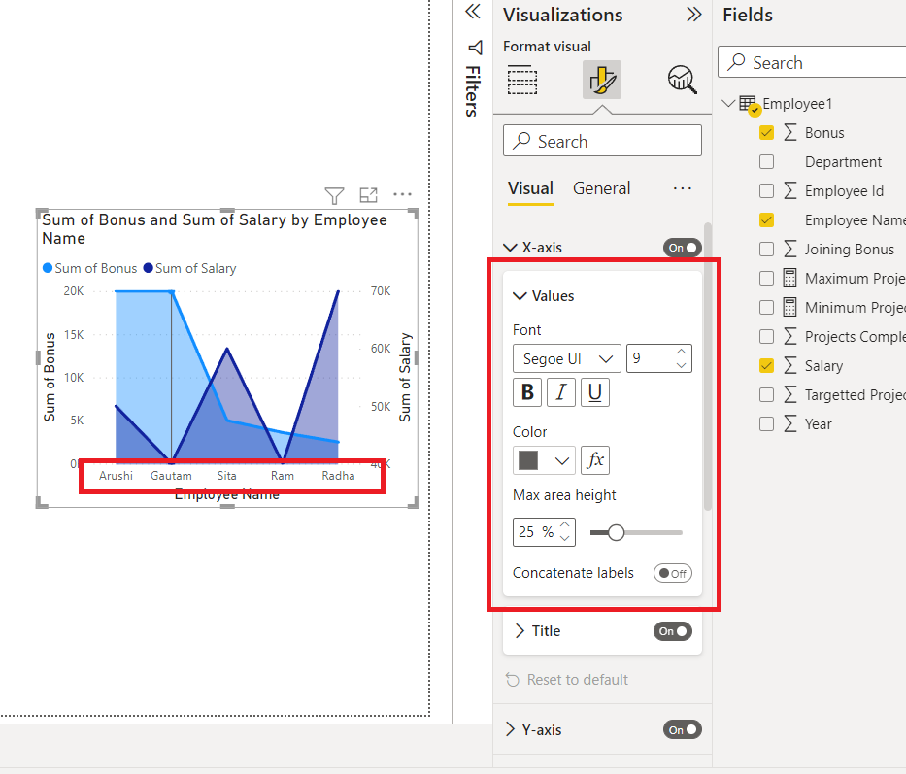

Power BI line and area chart visualization showing sum of bonus and sum of salary by employee with formatting options.

**Types :**

* **Basic Line Chart**: Single line showing one metric over time[7]
* **Multiple Line Chart**: Multiple lines comparing different metrics or categories[7]
* **Basic Area Chart**: Single area showing volume trends[6]
* **Stacked Area Chart**: Multiple areas stacked to show cumulative totals[8]
* **Line and Stacked Column Chart**: Combines line trends with stacked columns[7]
* **Line and Clustered Column Chart**: Shows trends alongside categorical comparisons[7]

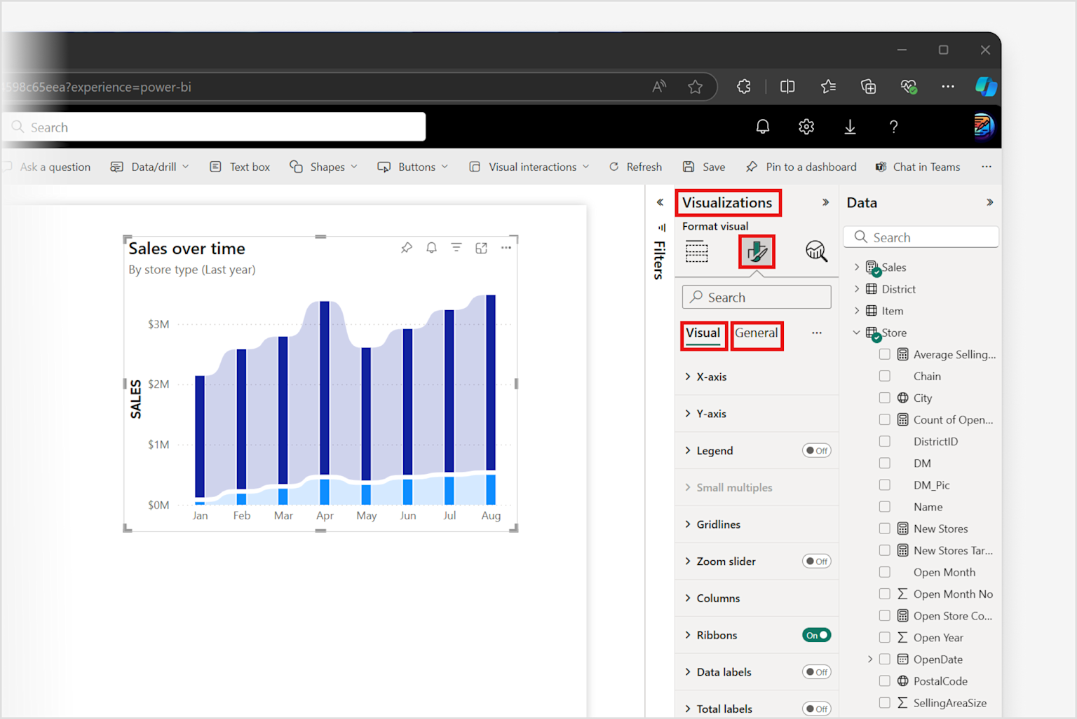

Power BI report displaying a line and column combo chart with formatting options in the Visualizations pane for configuring the visual's appearance and data.

**Real-World Use Cases :**

* **Stock Price Analysis**: Track stock prices over time with clear trend identification[7][9]
* **Sales Revenue Tracking**: Monitor monthly or quarterly revenue growth patterns[6][7]
* **Website Traffic Analysis**: Visualize visitor traffic patterns and seasonal variations[7]
* **Budget Performance**: Show cumulative spending against planned budgets over fiscal periods[6]

**Example**: An e-commerce company uses a line chart to track daily website conversion rates during a holiday sales campaign, quickly identifying when rates drop due to technical issues and enabling immediate corrective action.[7]

**Pie and Donut Charts :**

**Definition :**

**Pie charts** display data as slices of a circle, showing the relationship of parts to a whole. **Donut charts** are similar but have a hollow center that can display additional information.[10][11][12]

**Types :**

* **Basic Pie Chart**: Simple circular representation of proportional data[10]
* **Multi-level Pie Chart**: Shows hierarchical data with nested categories[10]
* **Basic Donut Chart**: Circular chart with hollow center[11][12]
* **Multi-ring Donut Chart**: Multiple concentric rings showing different data series[10]

**Real-World Use Cases :**

* **Market Share Distribution**: Show company market share percentages in an industry[10][13]
* **Budget Allocation**: Display how annual budget is distributed across departments[11][10]
* **Survey Results**: Visualize response distributions for customer satisfaction surveys[10]
* **Sales by Region**: Show revenue contribution from different geographical regions[10]
* **Customer Demographics**: Display age group distributions or customer segment breakdowns[13]

**Example**: A marketing team uses a donut chart to show campaign budget allocation: Digital Marketing (40%), Traditional Advertising (30%), Events (20%), and Content Creation (10%), with the center displaying total budget amount.[11]

**Scatter and Bubble Charts :**

**Definition :**

**Scatter charts** plot data points using two numerical axes to reveal relationships between variables. **Bubble charts** add a third dimension where bubble size represents an additional data variable.[14][15][16]

**Types :**

* **Basic Scatter Chart**: Two-dimensional data point plotting[14]
* **Bubble Chart**: Three-dimensional data visualization with size variation[16][14]
* **Dot Plot Chart**: Scatter chart with categorical data on horizontal axis[14]

**Real-World Use Cases :**

* **Customer Profitability Analysis**: Plot customer acquisition cost vs. customer lifetime value[14][15]
* **Product Performance**: Analyze relationship between marketing spend and sales revenue[15][16]
* **HR Analytics**: Correlate employee experience with salary and performance ratings[14]
* **Market Research**: Compare GDP per capita vs. happiness scores across countries[15]
* **Quality Control**: Plot defect rates against production volumes to identify patterns[14]

**Example**: A sales manager uses a bubble chart to analyze district performance, plotting sales per square foot (x-axis) vs. total sales variance (y-axis), with bubble size representing this year's sales volume, helping identify high-performing districts.[14]

**Table and Matrix Visuals :**

**Definition :**

**Tables** display data in rows and columns without hierarchical grouping. **Matrix visuals** provide pivot table functionality with hierarchical data organization, subtotals, and cross-tabulation capabilities.[17][18][19]

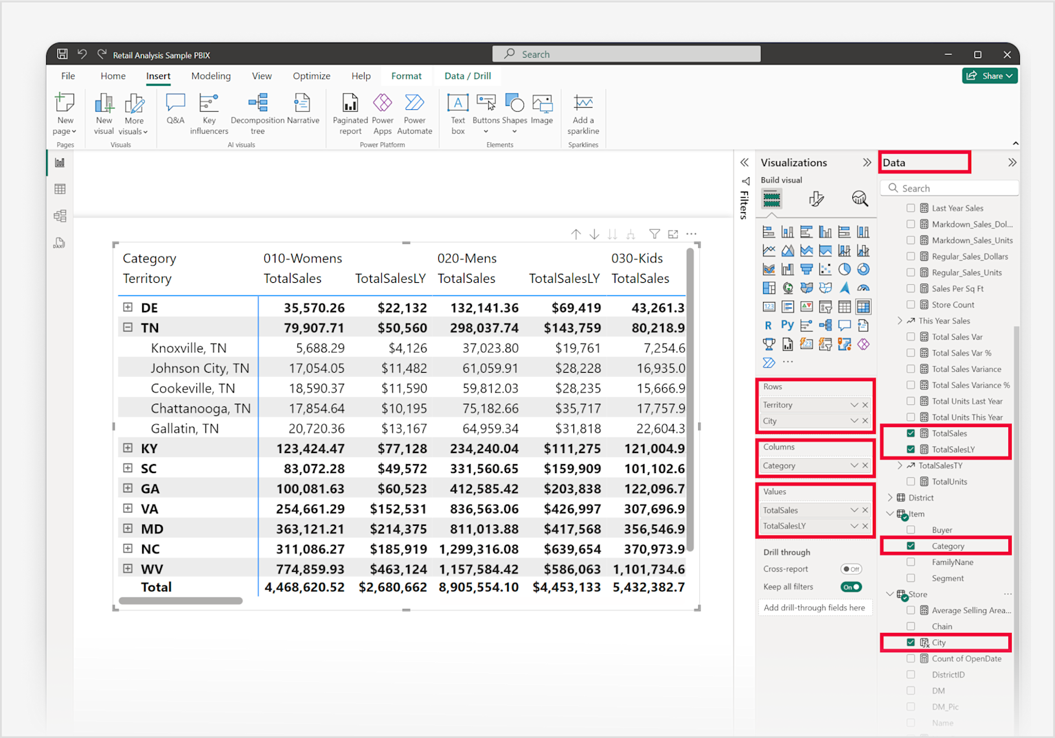

Power BI matrix visual example showing hierarchical sales data by territory and city, categorized by product and comparing total sales with last year sales.

**Types :**

* **Basic Table**: Flat tabular data display[20]
* **Matrix with Hierarchies**: Expandable/collapsible row and column groupings[18][19]
* **Conditional Formatted Matrix**: Color-coded cells based on value ranges[19]
* **Matrix with Subtotals**: Automatic calculation of group totals[18]

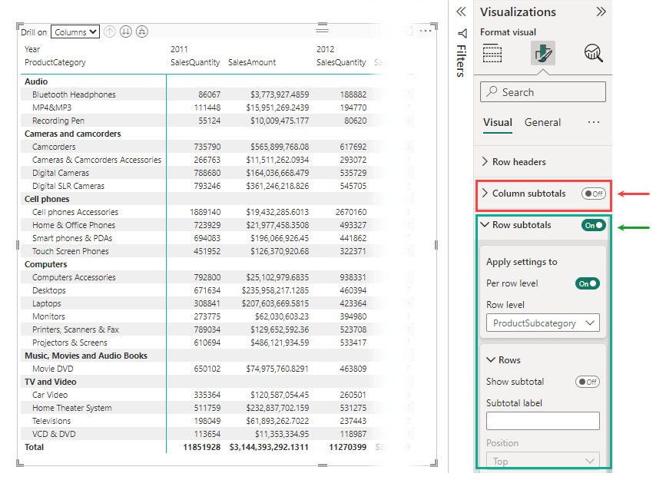

Power BI matrix visual example showing hierarchical product categories with sales data and formatting options for subtotals and row headers.

**Real-World Use Cases :**

* **Financial Reporting**: Create profit and loss statements with hierarchical account structures[18][19]
* **Sales Performance Dashboard**: Show sales by territory and product category with subtotals[18]
* **Inventory Management**: Display product quantities across multiple warehouses and time periods[17]
* **Academic Performance**: Student grades across subjects and semesters with averages[19]
* **Budget vs. Actual Analysis**: Compare planned vs. actual expenses across departments and months[20]

**Example**: A retail chain uses a matrix visual to analyze sales performance with product categories on rows, years on columns, and sales amount/quantity in values, enabling drill-down from categories to subcategories for detailed analysis.[19]

**KPI and Gauge Visuals :**

**Definition :**

**KPI visuals** display key performance indicators with actual values, targets, and trends. **Gauge charts** use circular arcs with needles to show progress toward goals.[21][22][23]

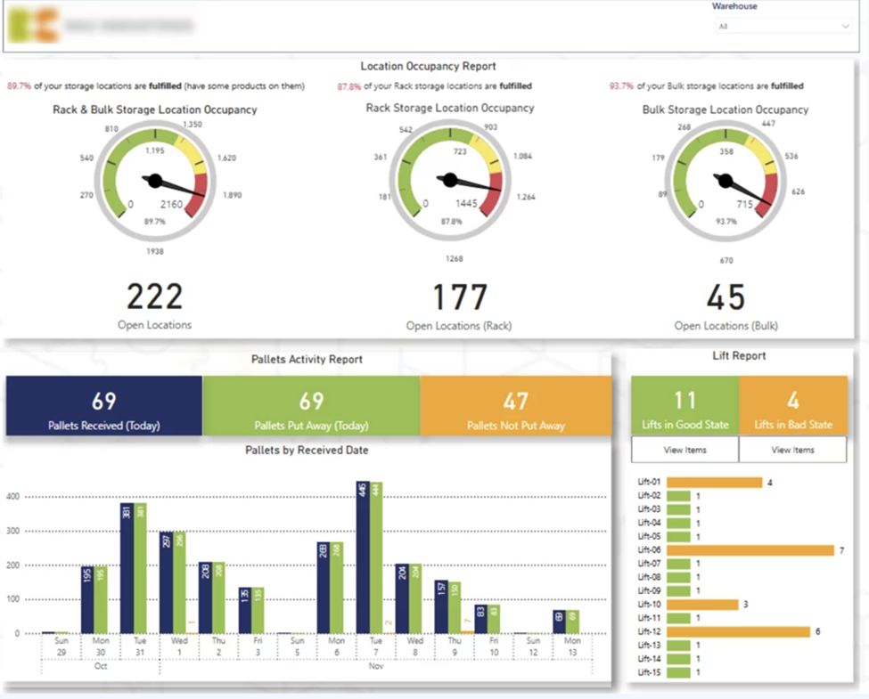

Power BI dashboard showing KPI gauge charts for storage location occupancy and bar/column charts for pallet and lift activity in a warehouse.

**Types :**

* **Basic KPI Visual**: Shows indicator, trend, and target[21][24]
* **Card Visual with KPI**: Single metric display with conditional formatting[24]
* **Radial Gauge**: Circular progress indicator[8][23]
* **Linear Gauge**: Horizontal or vertical progress bar[23]
* **Dial Gauge**: Speedometer-style indicator[23]

**Real-World Use Cases :**

* **Sales Target Tracking**: Monitor monthly sales performance against annual goals[21][22]
* **Customer Satisfaction Monitoring**: Track satisfaction scores with target thresholds[23][25]
* **Employee Training Compliance**: Visualize percentage of employees meeting training requirements[25]
* **Revenue Growth Monitoring**: Track quarterly revenue against growth targets[22][24]
* **Quality Metrics**: Monitor defect rates against quality standards[23]

**Example**: A car dealership tracks sales team performance using a gauge chart showing average monthly sales ($180K) against a goal of $200K, with minimum ($100K) and maximum ($250K) ranges, enabling quick assessment of progress toward targets.[8]

**Map Visuals :**

**Definition :**

Map visuals display geographical data using various mapping techniques to show location-based insights and spatial relationships.[26][27]

**Types**

* **Basic Maps**: Simple pin-based location mapping with bubble sizing[26][27]
* **Filled Maps (Choropleth)**: Color-coded regions based on data intensity[27][26]
* **Shape Maps**: Custom geographical boundaries with color coding[26][27]
* **ArcGIS Maps**: Advanced mapping with spatial analysis capabilities[28][26]
* **Globe Map**: 3D spherical visualization with bar charts and heat maps[28]

**Real-World Use Cases :**

* **Sales Territory Analysis**: Visualize sales performance across geographical regions[26][27]
* **Customer Distribution Mapping**: Show customer concentrations and market penetration[26]
* **Supply Chain Optimization**: Map warehouse locations and delivery routes[27]
* **Real Estate Analysis**: Display property values and market trends by location[26]
* **Environmental Monitoring**: Track pollution levels, weather patterns, or natural disasters[26]

**Example**: A global retailer uses a filled map to visualize revenue by country, with darker colors indicating higher sales volumes, helping identify expansion opportunities and resource allocation needs.[26]

**Funnel Charts :**

**Definition :**

**Funnel charts** visualize sequential processes where values typically decrease at each stage, resembling an inverted triangle that narrows toward the bottom.[8][29]

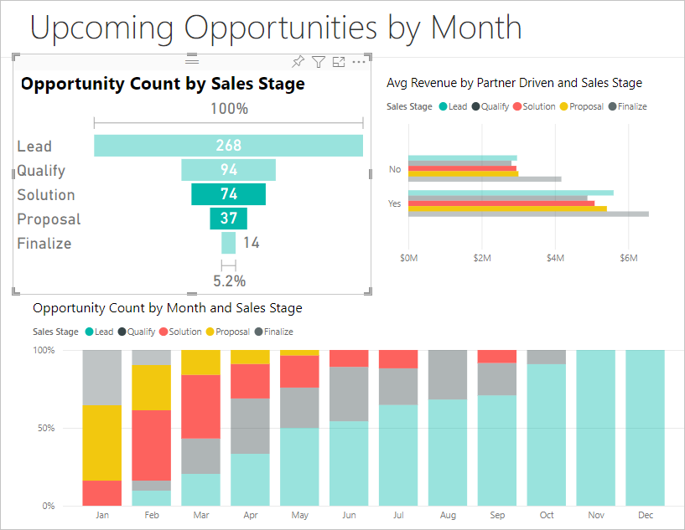

Power BI dashboard showing sales opportunity counts by sales stage and month using funnel-like stacked bar charts and average revenue comparison.

**Types :**

* **Basic Funnel Chart**: Sequential stages with decreasing values[8]
* **Conversion Funnel**: Process flow with conversion rates[29]

**Real-World Use Cases**

* **Sales Pipeline Management**: Track leads through qualification, proposal, and closing stages[29]
* **Customer Acquisition Journey**: Monitor user progression from awareness to purchase[29]
* **Recruitment Process**: Visualize candidate flow from application to hiring[29]
* **E-commerce Checkout Flow**: Identify drop-off points in online purchase process[29]
* **Marketing Campaign Analysis**: Track user engagement from impression to conversion[29]

**Example**: An e-commerce company uses a funnel chart to analyze their checkout process: Website Visitors (10,000) → Cart Additions (3,000) → Checkout Initiated (1,500) → Payment Completed (1,200), identifying that 20% of users abandon during checkout.[29]

**Waterfall Charts :**

**Definition :**

**Waterfall charts** show cumulative effects of sequential positive and negative changes on an initial value, displaying how you arrive at a final result.[8][30][31]

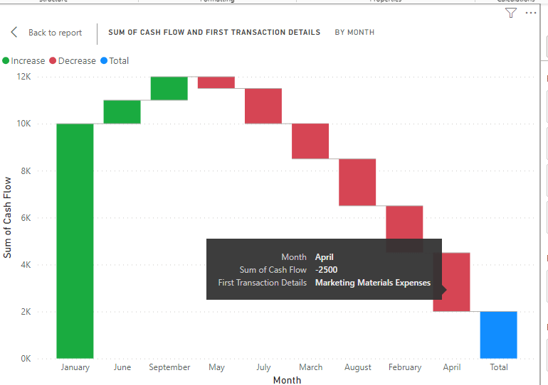

Power BI waterfall chart showing monthly increases and decreases in cash flow with detailed tooltip for April expenses.

**Types :**

* **Basic Waterfall Chart**: Sequential value changes with running totals[30]
* **Breakdown Waterfall**: Shows contributing factors to changes[32]

**Real-World Use Cases :**

* **Financial Variance Analysis**: Show how budget deviations accumulated over time[30][31]
* **Profit and Loss Breakdown**: Analyze factors contributing to net income changes[8][30]
* **Inventory Movement**: Track stock level changes through purchases, sales, and adjustments[31]
* **Cash Flow Analysis**: Visualize cash inflows and outflows affecting account balance[8][30]
* **Project Budget Tracking**: Monitor how scope changes affect total project costs[30]

**Example**: A company uses a waterfall chart to analyze annual profit changes: Starting Profit ($500K) + New Sales (+$200K) - Increased Costs (-$150K) - Marketing Expenses (-$50K) = Final Profit ($500K), clearly showing each factor's contribution.[31]

**Combo Charts :**

**Definition :**

**Combo charts** combine multiple visualization types in a single chart, typically mixing columns/bars with lines to show different data types or scales.[1]

**Types :**

* **Line and Column Chart**: Combines trend lines with categorical bars[1]
* **Line and Stacked Column**: Shows trends alongside compositional data[1]
* **Line and Clustered Column**: Displays trends with comparative categories[1]

**Real-World Use Cases :**

* **Sales and Profit Analysis**: Show sales volume (columns) and profit margin (line) over time[1]
* **Performance vs. Target**: Display actual performance (columns) against targets (line)[1]
* **Temperature and Rainfall**: Weather data combining precipitation (bars) and temperature (line)[1]

**Treemap Charts :**

**Definition :**

**Treemap charts** use colored rectangles of varying sizes to represent hierarchical data, with rectangle size proportional to the data value.[8]

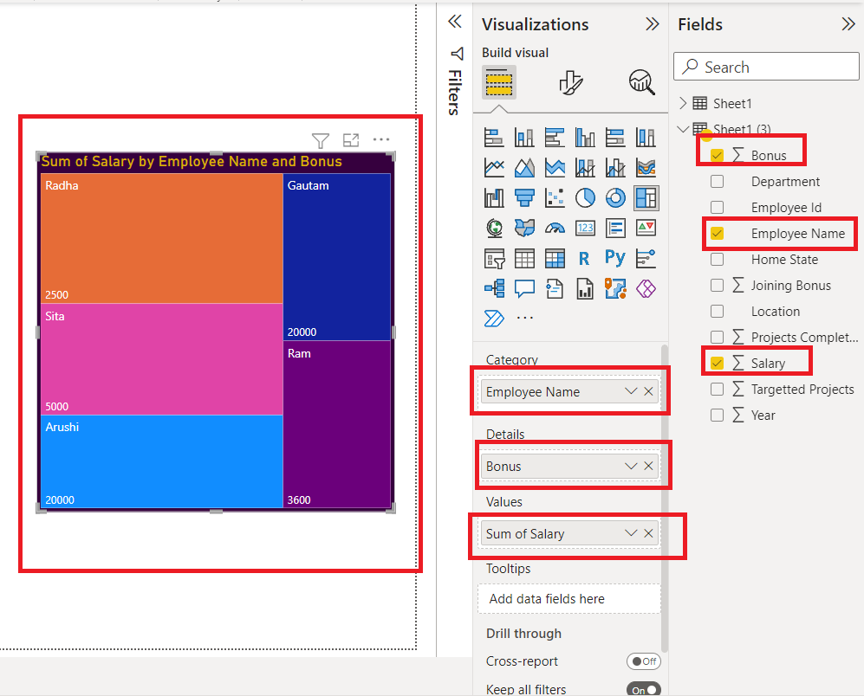

Power BI treemap visualization showing sum of salary by employee name and bonus with corresponding field settings.

**Real-World Use Cases :**

* **Portfolio Analysis**: Show investment allocations across asset classes and individual holdings[8]
* **Website Analytics**: Display page views across different site sections and pages[8]
* **Budget Visualization**: Show spending across departments and expense categories[8]
* **Market Capitalization**: Visualize company sizes across different industry sectors[8]

This comprehensive documentation provides the foundation for selecting and implementing appropriate Power BI visuals based on your specific data analysis needs and business requirements. Each visual type excels in particular scenarios, and understanding their strengths enables more effective data storytelling and decision-making.